**Experiment No. 5**

**Aim:**

Design an obstacle detector and distance measuring device.

**Apparatus:**

Arduino, Breadboard, Ultrasonic sensor, wires,LED

**Circuit Diagram:**

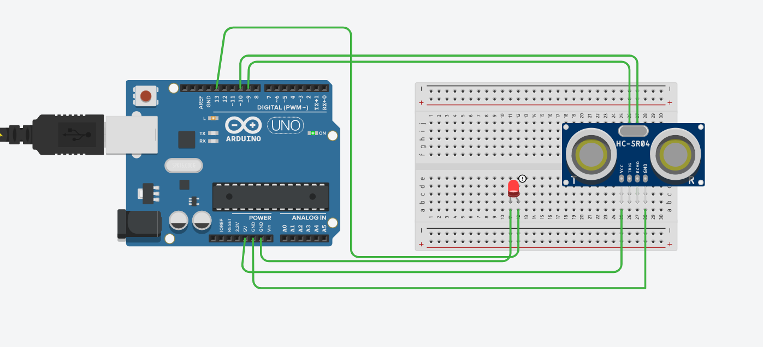

**Source code:**

**const int trigPin=9;**

**const int echoPin=10;**

**long duration;**

**int distance;**

**void setup()**

**{**

**pinMode(13,OUTPUT);**

**pinMode(trigPin,OUTPUT);**

**pinMode(echoPin,INPUT);**

**Serial.begin(9600);**

**}**

**void loop()**

**{**

**digitalWrite(trigPin, LOW);**

**delayMicroseconds(2);**

**digitalWrite(trigPin,HIGH);**

**delayMicroseconds(10);**

**digitalWrite(trigPin,LOW);**

**duration=pulseIn(echoPin,HIGH);**

**distance=duration*0.034/2;**

**if(distance<20){**

**digitalWrite(13,HIGH);**

**delay(100);}**

**else**

**{**

**digitalWrite(13,LOW);**

**delay(100);**

**}**

**Serial.print("Distance:");**

**Serial.println(distance);**

**}**

**Precautions:**

1. Don’t touch live wires and components.
2. Always do the connections without connecting the arduino with main supply.

**Problems Faced:**

1. To turn the LED on at a particular distance.
2. Problem faced in uploading the code due to errors in coding.

**Solutions to problems faced:**

1. To solve the problem of connections, I focussed on each wire and do the connections.
2. To solve the error in coding, I declare the right pins as constants.

**Learning and outcomes:**

1. I learn how to use ultrasonic sensor.
2. Also how to turn LED on using ultrasonic sensor.